BMP Europe Ltd
Tree Hugger Manual and Installation Guide

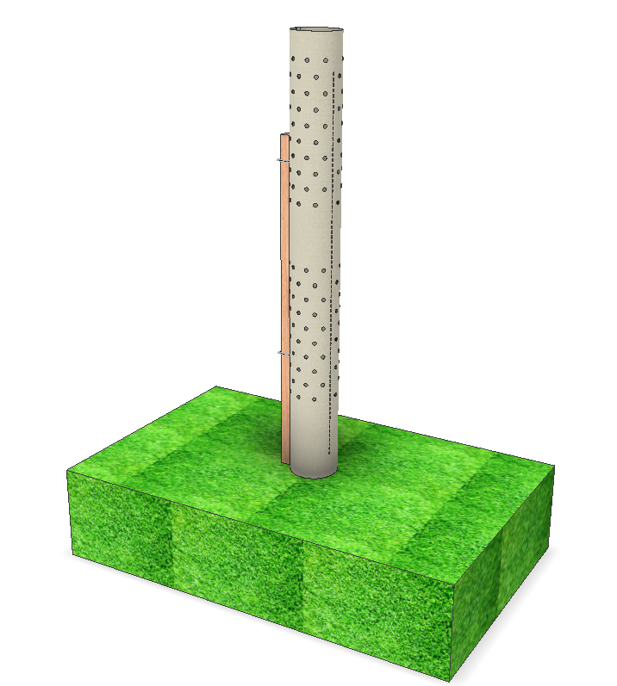

Table of Contents

Contents
Introduction 3
Handling 3
Storage 3
Preparation 4
Installation 6
Contacts 7

Introduction

The BMP Tree Hugger TM is an innovative solution to a challenging environmental issue. As we grow to be more conscious of the effect of plastics on our environment, BMP realised through a rich experience in processing polymers that a solution to replace plastic tree guards is possible. The use of a Polymer derived from renewable rosin tapped from pine trees blended with a plant based natural fibre offers a unique, environmentally friendly, and sustainable alternative to the plastic options already established and used today.
BMP Europe Ltd have a wealth of experience in designing, developing and processing polymer-based products for a wide range of applications. The key objective for the Tree Hugger is to eliminate plastic from the environment and reduce the Co2 generated through manufacturing and transportation. The woven natural fibre allowed us to explore benefits such as cost, ethical sourcing, sustainability of supply, reduced transportation, reduced weight, and improved manual handling.
The Tree Hugger provides as superior environment allowing growth of the sapling whilst also protecting it from wildlife and any potentially harmful herbicide sprays. The natural cotton fibres allow an excellent level of light to permeate the structure of the fabric and diffuse on the surface of the growing sapling. Apertures within the fabric of the product allow for excellent air movement within the enclosure and adds an additional source for light permeation.
The Tree Hugger is designed and manufactured to be harmless to the environment and biodegradable under natural environmental conditions. Under these normal conditions the Tree Hugger will be completely biodegradable within a 10 year period.

Storage

The Tree Hugger is packaged in a large bag with a cable tie securing the contents together at the top. If the product is to be stored for a protracted period of time, then it must be stored in a dry, cool location where strong levels of ultraviolet light are unable to penetrate the enclosure.
The bagged Tree Huggers are supplied with fixed cardboard ends for protection. These must be kept with the product whilst in storage and delivery to the planting site. The bagged Tree Huggers must be kept in an upright position on the cardboard ends. The product must not be laid flat on it’s side.

Handling / Packaging

The Tree Huggers are packaged in a nested group of 5, consisting of various diameters concentrically placed within the bodies of each other. The cable ties are pre-attached to be positioned easily around the supporting structure.
Reasonable care should be taken when handling the product to prevent crushing or excessive forces on the circumference of the shelter whilst transporting

Preparation

The Tree Hugger requires suitable support through the use of a wooden stake or similar.
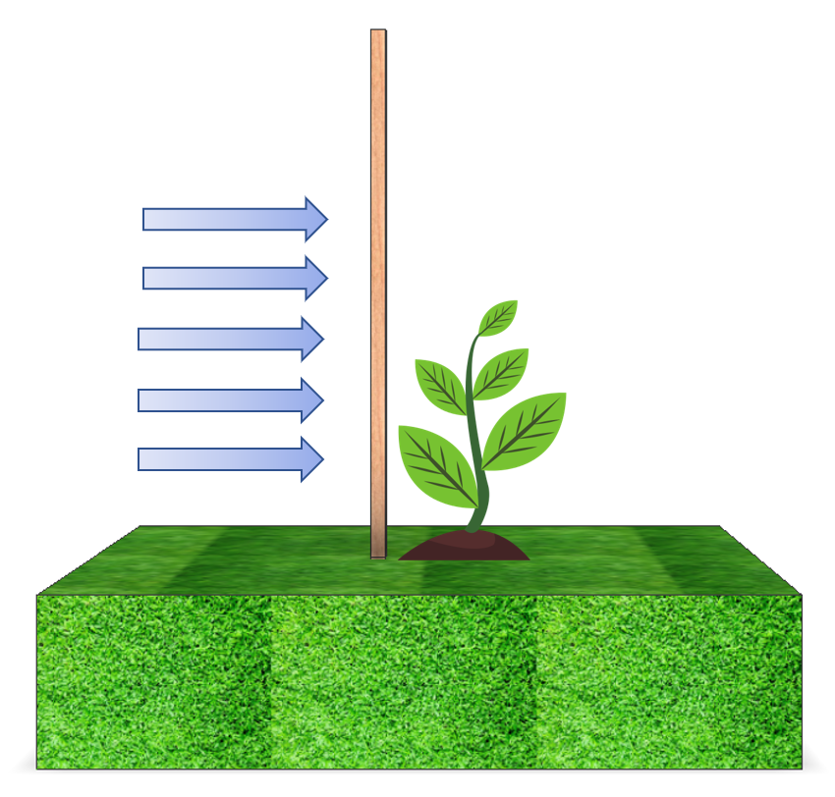
As a general guide, the overall length of support post / stake should be longer than the shelter by approximately 20% to allow full support towards the top of the Tree Hugger once the stake has been put into position.
The position of the stake should be on the windward side of the planted sapling, especially if there are strong prevailing winds at the location.

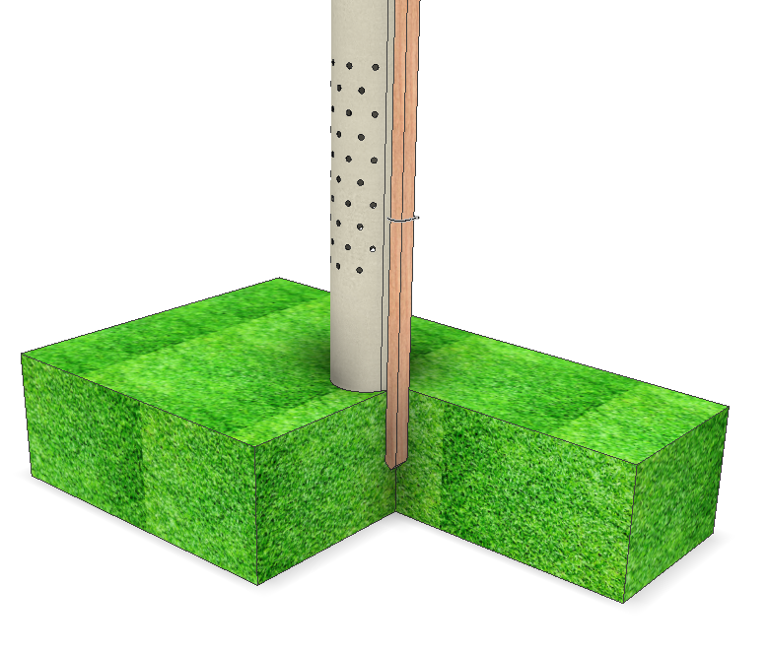
The stake should be driven into the ground using a mallet, where the stake is of suitable size to undertake this action. Ideally the stake should be knocked into the ground approximately 1/3 of its height to ensure the stake is firmly secured and can act as adequate support for the sapling and Tree Hugger.
The top of the stake should be below the top rim of the Tree Hugger and above the top cable tie.

Installation

The Tree Hugger is designed to be easy and straight forward to install

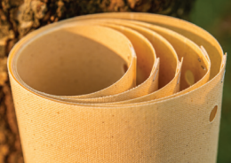 | - Select a shelter from the nesting to use for the planting installation.
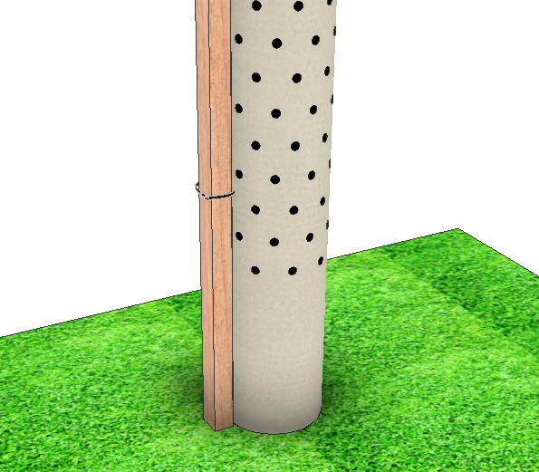 | - Position the shelter over the tree, taking care to prevent any damage to protruding tree branches. Ensure that the lower cable tie is looped over the top of the stake.
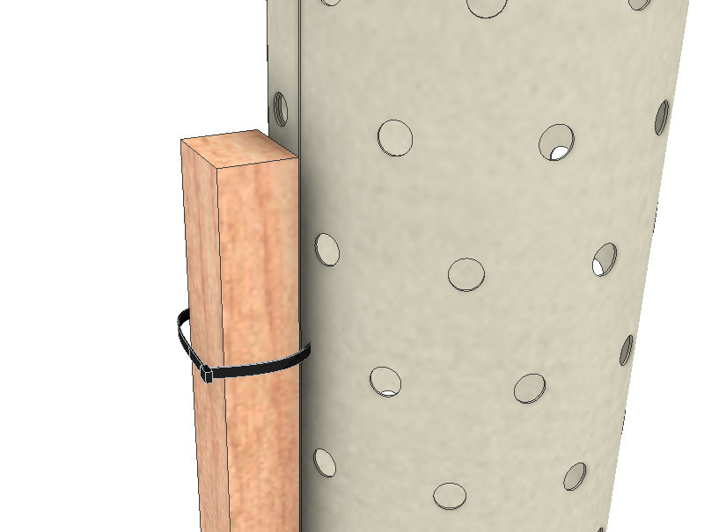 | - Continue sliding the Tree Hugger over the tree and ensure to loop the top cable tie over the stake and continue to lower the Tree Hugger.
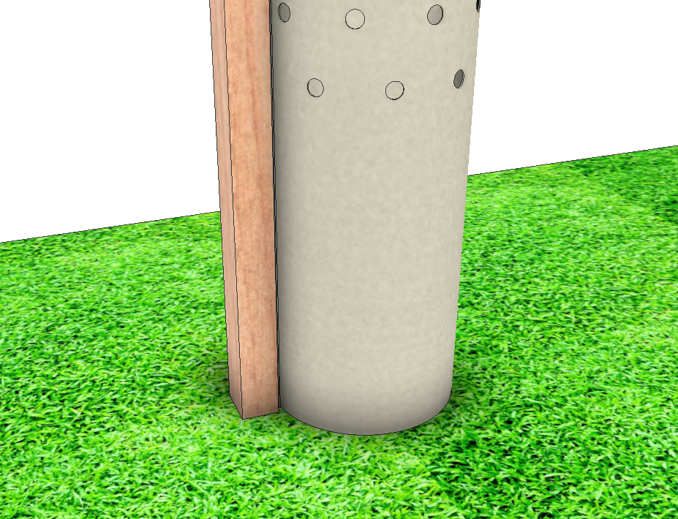 | - Ensure that the Tree Hugger has penetrated the ground slightly (approx.. 2mm) – Do not force into the ground. Then tighten the cable ties sufficiently to ensure that the Tree Hugger is fully secured against the stake.
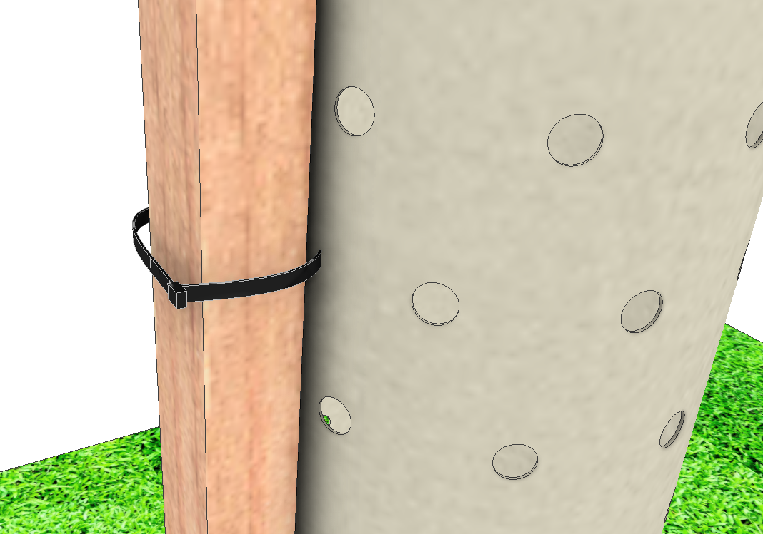 | - Once both cable ties have been secured against the stake, wrap the cables tie over themselves to prevent wildlife catching the loose tie material.

Contacts

BMP Sales
Telephone: 01282 772000
Email: info@bmpeurope.com
Web: www.bmptreehugger.com

